**PRACTICAL NO 8**

* Write PHP Scripts for

1. Retrieving data from HTML Form

Input:

HTML

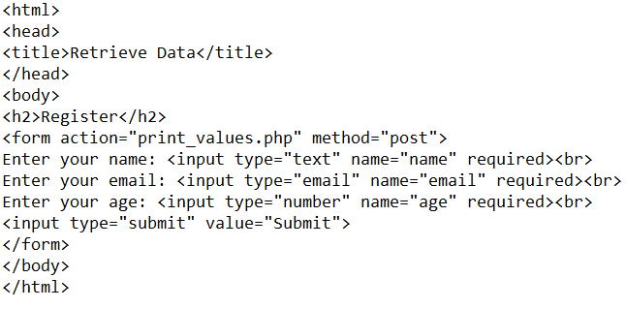

PHP

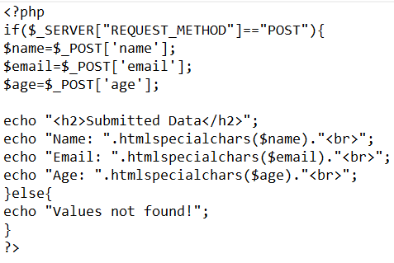

Output:





2. Performing certain mathematical operations such as calculating factorial / Finding Fibonacci Series

Factorial Input:

HTML

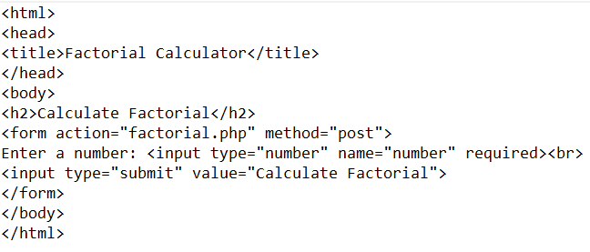

PHP

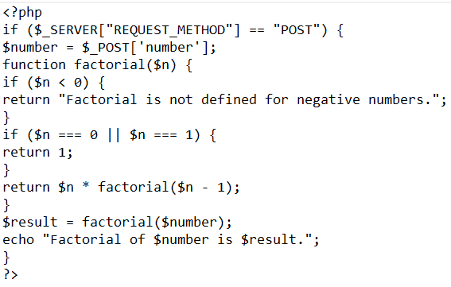

Output:

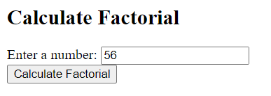



Fibonacci Input:

HTML

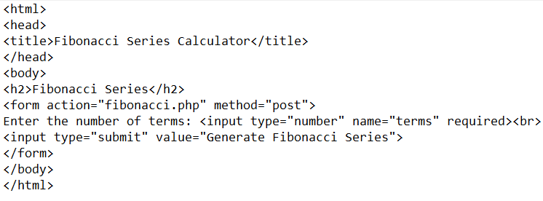

PHP

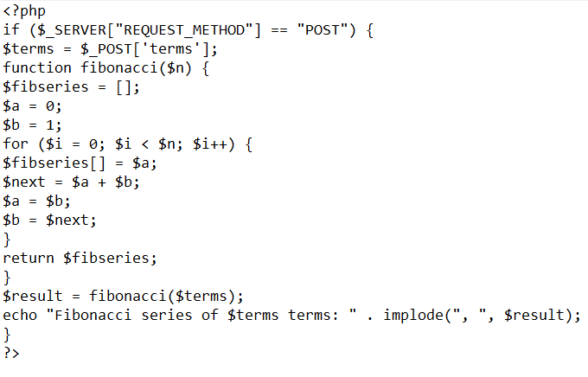

Output:

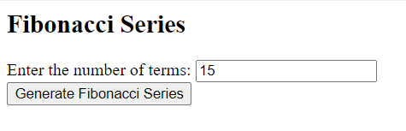



3. Working with Files (Reading / Writing)

Input:

HTML

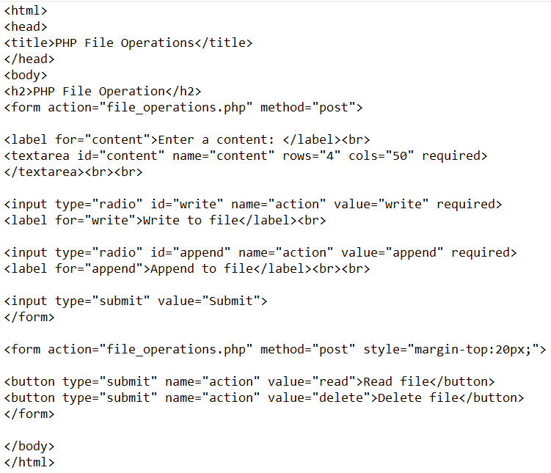

PHP

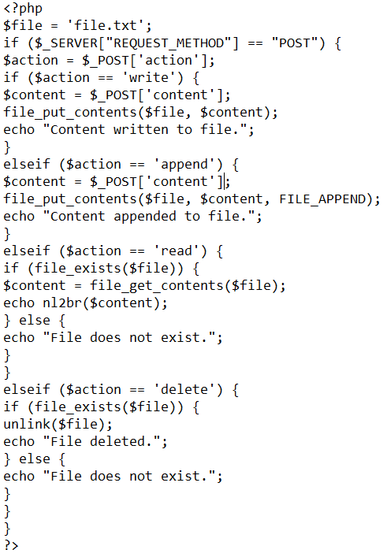

Output:





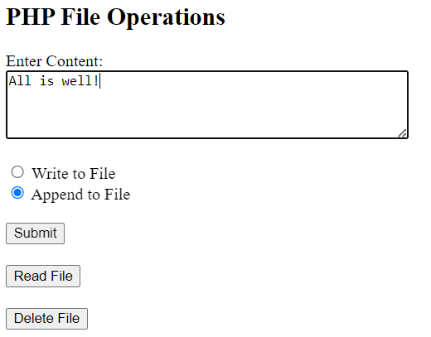



When you click on Read File button it will show the following output



When you click on Delete File button it will show the following output

and the file will be deleted



When you click on Read File button it will show this as file is deleted

